PROJECT REPORT : ClariDocs Ai
An ai based application to summarize, analyze and categorize legal documents Project Developers: M Koushik 2403A52258
Mohammed Eliyas 2403A52257 Hrishikesh Sharma 2403A52274

Abstract
Due to the sudden growth in digital documents there is an urgent need of tools that help us understand all these huge documents in a short amount of time. For this problem our solution is ClariDocs Ai , an ai powered tool that summarizes the documents , extract the key words and flags potential risks
Instead of relying on large language models which can raise privacy concerns , ClariDocs uses simple classic ml algorithms like tf -idf and logistic regression. This approach is very safe because it keeps all the data in the system itself.
We gathered data from trusted resources from different domains to recognize different document types and apply specific rules to flag important risks. With this we built a tool that easy to use and cn run on any system.

Introduction and Problem Statement
Today business and healthcare domains are daily getting huge unstructured data, manual checking all these papers is very difficult and a time taking and resource taking process and its very expensive.
On top of all these there is ahigh chance of human errors which can lead to serious consequences
That’s why there is a need for automated , intelligent ai systems which can do all the things a human can do but in a sufficient and fast way.

Methodology
The system uses datasets from different domains like health , legal , research and insurance. And with the help of tf-df we vectorize the sentences and classify them using logistic regression , and rank these sentences based on their importance. We use regex to identify risk patterns , and we classified risks into 3 main categories high , medium and low.
3.1 User flow
User enters the website
Selects the domain of their document Upload the document
And get key details of that document like , summary , risks , confidence score and flags found

Results

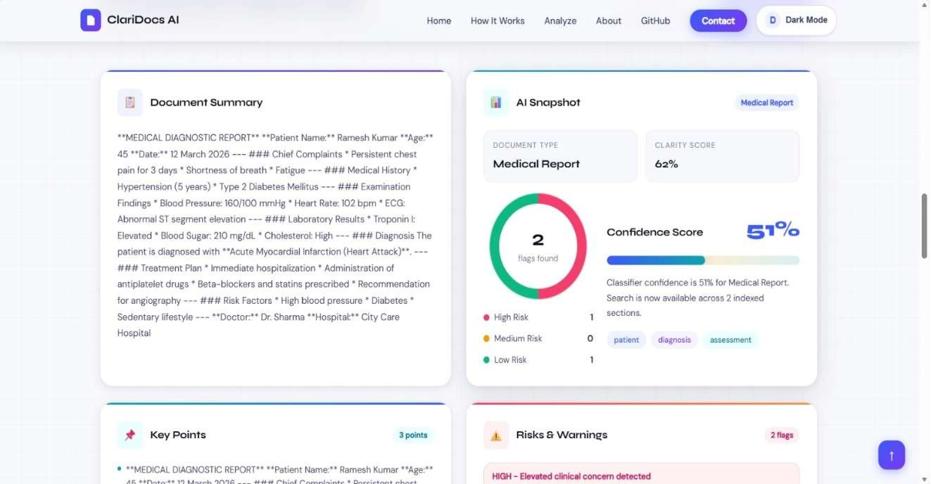
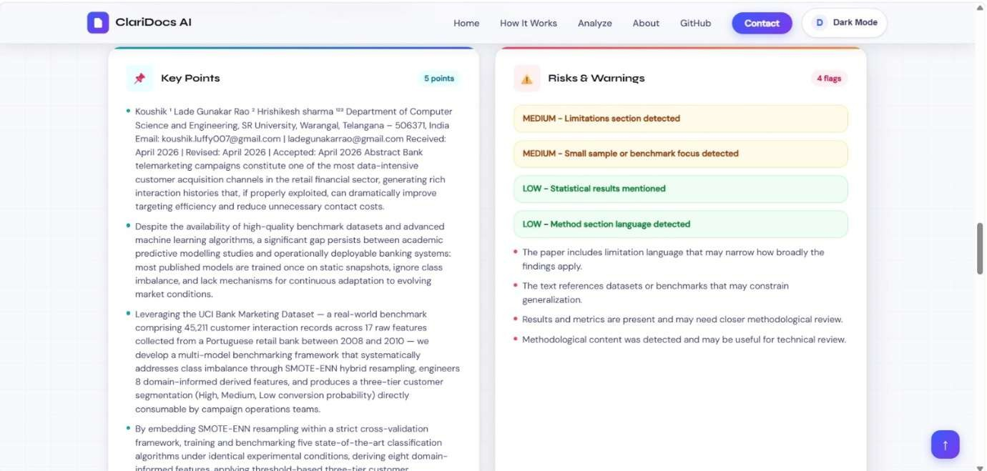

Model Performance for different documents: Predicted Label: legal_contract
Probabilities Breakdown: legal_contract: 61.96%
insurance_policy: 15.55%
research_paper: 11.95%
medical_report: 10.52%

Model performance metrics:

Category | Precision | Recall | F1-Score
Legal Contract | 1.00 | 1.00 | 1.00
Medical Report | 1.00 | 1.00 | 1.00
Insurance Policy | 1.00 | 0.95 | 0.97
Research Paper | 0.92 | 1.00 | 0.96

CONCLUSION
ClariDocsAi demonstrates that we can perform high efficient document analysis using classic machine learning algorithms like logistic regression , without any need for large language models.

